

FALCON’s Response to Flipkart for Supply of Linear CBS 10.8K PPH
December 10, 2024

Kind Attention –

Mr. Shreesha
Mr. Nishanth
M/s Flipkart

Offer Ref: F24-00420; Date: 10-12-2024

Subject – Techno -Commercial Offer of Linear Cross Belt Sorter 10.8K PPH

We are pleased to submit our Techno-Commercial Offer in response to your RFP.
As you will note, we have studied your requirements in great depth and, along with the information collected during the workshops and calls with you, we have put together a detailed technical proposal laid out in various sections and sequenced to enable you to understand our proposed solution and to re-enforce our commitment to be your partner in this strategic initiative.
In subsequent sections, we have highlighted the capabilities and experiences of Falcon Autotech with sections on our Automation Technologies and references.
To conclude, I would like to add my personal commitment, on behalf of Falcon Autotech. As we move through the RFP process, please do not hesitate to contact me and my team. We will be pleased to assist you for any further information or clarifications that you might have.

Best Regards,
Sandeep Bansal
Chief Business Officer

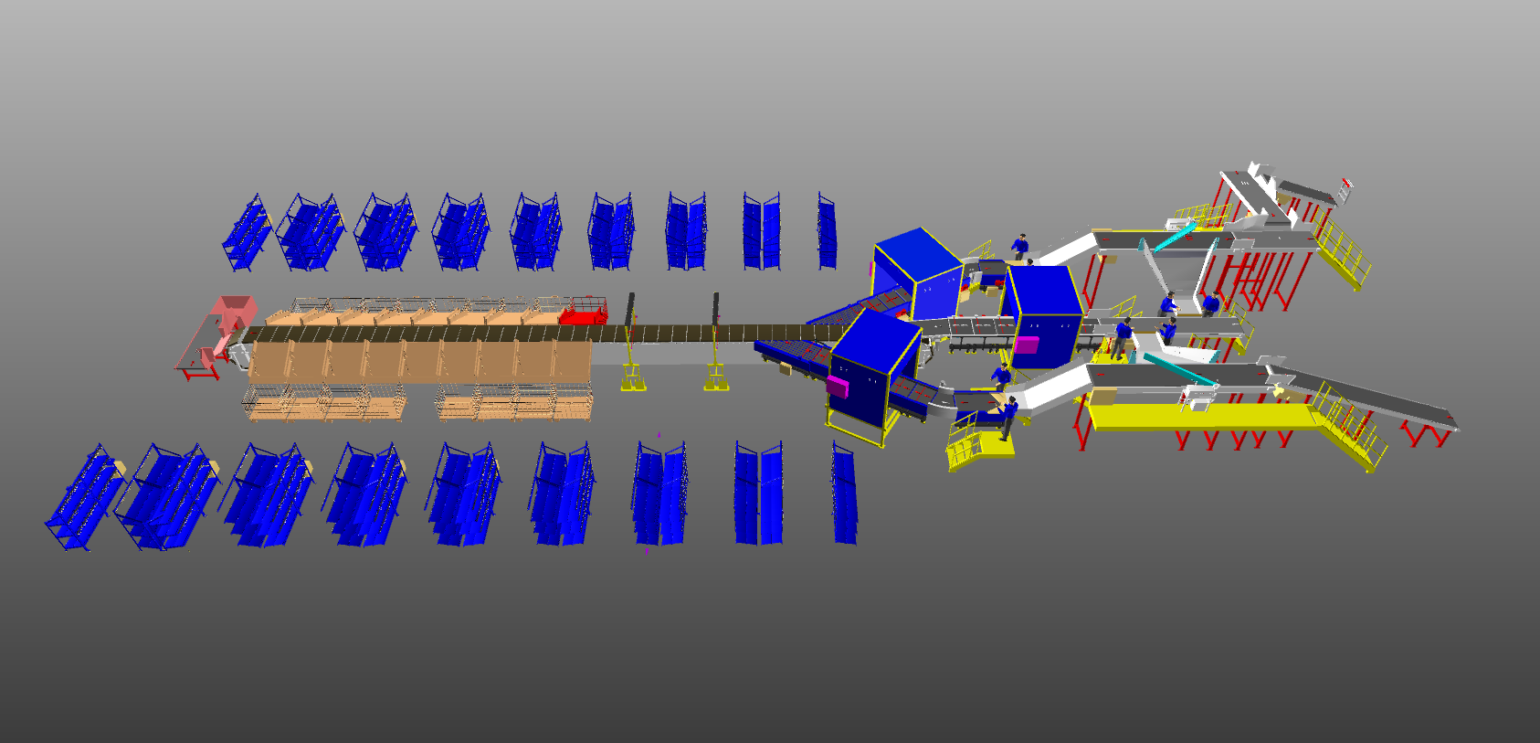
Response to RFP for Linear Cross Belt Sorter 10.8K PPH

Proposal Reference – F24-00420

Falcon Autotech Private Limited
Plot No. 87, Sector Ecotech-1, Extention-1, Greater Noida, Uttar Pradesh 201308.

Contact – Sanyog Pratap Singh
Asst. Manager
Mob - +91 8750052591
Sanyog.singh@falconautoonine.com

Contents
Contents 4
1. Glossary 7
2. Executive Summary 8
3. Company Profile 9
4. Falcon’s Experience and Achievements in Sortation Space Globally 13
5. Reference Projects 15
5.1 Project 1- (CEP Client, UK) 15
5.2 Project 2- (CEP Client, Riyadh) 16
5.3 Project 3- (Client – Courier Express Shipment, Dubai & Jeddah) 17
5.4 Project 4- (CEP Client, Sydney) 18
5.5 Project 5- (Client – E-Commerce, India) 19
5.6 Project 6- (Ecommerce Client, India) 20
6. Handled Shipment Spectrum 21
6.1 Shipment size loadable on the sorter 21
6.2 Shipments to be loaded on Sorter shall have the following characteristics: 21
6.3 Shipment not loadable on the sorter 22
6.4 Pictures of Sortable Shipments 23
7. Proposed System Description 24
7.1 Objective 24
7.2 Summary of the System 24
7.3 Main benefits of the proposed solution 25
8. Concept Description 26
9. Layout View 27
10. Proposed System Capacity Calculations 28
10.1 Sorter System Capacity 28
11. System description 29
11.1 Infeed System 29
11.1.1 Infeed System 30
11.1.1.1 Straight and Inclined Powered Belt Conveyor 30
11.1.2 Conveyor BOQ 32
11.2 Induction to Sorter 33
11.2.1 Feedlines 33
11.2.1.1 Weighing Conveyor 34
11.2.1.2 Receiving Conveyor 34
11.2.1.3 Buffer Conveyors 35
11.2.1.4 Powered Belt Merges & ZTR Curves (Pic for ref.) 35
11.2.2 Linear Sorter 36
11.2.3 Sorting Output 37
11.2.3.1 Collection Chute 37
11.2.3.2 Rejection Chute 38
11.2.3.3 Sortfail Chute 39
12. Description of Components of Equipment 40
12.1 Cross Belt Sorter - 40
12.1.1 CBS Carrier 40
12.1.2 Servo Roller 41
12.1.3 Chassis 41
12.1.4 Carrier Wheels 41
12.1.5 Non-contact based linear motor drive 42
12.1.6 Power Transmission 42
12.1.7 Data Transmission 42
12.1.8 Carriers positioning System. 43
12.1.9 Technical specifications of Sorter 43
12.2 Scanning & Sensing on Linear Sorter 44
12.2.1 Automatic Barcode Scanning 44
12.2.2 Shipment Positioning System. 44
12.3 Steel Works – Mezzanine & Staircases- (In Flipkart’s Scope) 45
12.3.1 Operator Platform & Maintenance Platform 45
13. Proposed System Technical Details 46
13.1 Mechanical equipment 46
13.2 Electrical Equipment 47
13.3 Control System 47
14. Electrical System 47
14.1 Reference Picture of Power Distribution Panel 47
14.2 Main Control Panel (Reference) 48
14.3 Induct Stations Control Panel (Reference) 48
15. Controls Architecture (Ref.) 49
16. IT Architecture (Ref.) 50
16.1 HAA Server (In Flipkart Scope) 50
17. Falcon’s WCS CONTROLIT 51
18. Falcon’s Visual Inspection System (SCADA) 52
19. Key Components Make 52
20. Principle of Safety 53
20.1 E-Stops 53
21. Program Organisation 54
21.1 Program/ Project Schedule 54
21.2 Program Management 54
22. Flipkart Responsibility 54
22.1 Flipkart Responsibilities During the Assembly and Commissioning Phase 54
22.2 Responsibilities of Flipkart During the Tests 55
22.3 Flipkart Responsibilities During the Training 55
23. Warranty Period 56
24. Exclusions 57

Glossary

S. No. | Term | Description
1 | RFP | Request For Proposal
2 | PPH | Shipments Per Hour
3 | ICR | Intelligent Character Recognition
4 | MEZZ | Mezzanine
5 | LSM | Linear Synchronous Motors
6 | AC | Alternating Current
7 | DC | Direct Current
8 | PLC | Programmable Logic Controller
9 | IT | Information Technology
10 | BOQ | Bill Of Quantity
11 | I/O | Input/ Output
12 | PDP | Power Distribution Panel
13 | PC | Personal Computer
14 | UPS | Uninterrupted Power Supply
15 | CBS | Cross Belt Sorter
16 | MDR | Motor Driven Roller
17 | DAP | Design Approval Phase

Executive Summary
Falcon is pleased to confirm its great interest in responding to this Flipkart RFQ of Linear CBS Our team has been working closely with the relevant stakeholders, with a clear commitment to listening and understanding your needs and ensuring this project's success.
Following the same objective for the CBS system, we are happy to offer a compliant solution meeting all technical and operational requirements, high-performance, optimized, tailor-made, fast and secure planning, and a competitive price.

Our solution is based on the following key characteristics:

• Linear CBS for shipment sorting, employing linear cross belt technology, have been designed to handle a throughput of 10,800 shipments per hour.
• This Linear CBS is equipped with 1+2 Nos Automatic induct lines.
• The System is having its own Volume Distribution system which transports the volume from packing lines to the VDS Chutes.
• In the system, 16 Nos Collection Chute, 1 rejection chute, 1 supplementary chute & 1 Sort fail recirculation line.
• The system layout has been meticulously planned to facilitate smooth operational flow, ensuring efficient movement of personnel.

A tailor-made and simple layout designed explicitly for Flipkart. The proposed layout is the result of the technical requirements in the RFP document and our discussions with the relevant stakeholders during our meeting.

- Falcon's reliable Shipment sortation systems
These systems are globally being used by most innovative brands such as Flipkart, Amazon Delhivery, Asendia, Fastway and many more. The main and critical components of the FALCON Autotech sorter building blocks, like wheels, motors, belts, bearings, Bus Bars, Communication platforms, PLCs etc., are sourced from some of the best suppliers in the world, such as SEW, Siemens, SICK, Faigle, Vahle and Forbo. This strategic baseline of sourcing policy allows Falcon's customers to be fully confident in the systems' robustness and reliability.

- Commitment to quality systems
Demonstrating Falcon's clear commitment to the Flipkart satisfaction, the shipment sortation system, parts and services will be under warranty for 12 months from installation go-live.

- A strong and already successful partnership between Flipkart & Falcon
Flipkart has been Falcon's customer since long and using multiple Falcon Systems. For each project, several advanced tools to improve the service's quality and efficiency are provided: Service Desk, Hotline support, remote access, regular governance meetings and monthly reports.

Company Profile
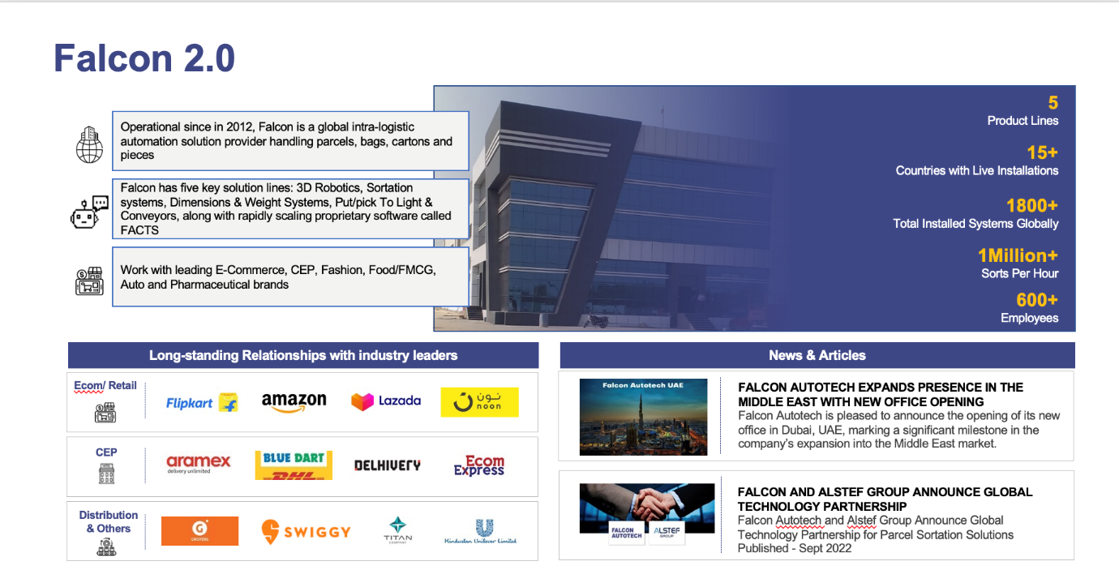
Falcon Autotech (Falcon) is a global intralogistics automation solutions company. With over 10 years of experience, Falcon has worked with some of the most innovative brands in E-Commerce, CEP, Fashion, Food/FMCG, Auto and Pharmaceutical Industries. With our proprietary software and robust hardware integration capabilities, Falcon designs, manufactures, supplies, implements, and maintains world-class warehouse automation systems globally. Falcon’s strong research and development team and the continuous focus on innovation reflect our strong solution line around Sortation, Robotics, Conveying, Vision Systems and IOT. Falcon has done over 1,800 installations across 15 countries on four continents.

Falcon Autotech is currently among the top 15 intralogistics automation company, our vision is to become top 10 intralogistics automation company in our focused product lines.

The team started out in 2004 solving special purpose automation problems for clients and later established Falcon Autotech in 2012 with strong focus on building standard technology stack spanning across Hardware, Firmware and Software to tackle bigger Supply Chain problems around warehouse automation and material handling. Over the decade, Falcon has made rapid strides and has carved out a niche in some of the world's most cutting-edge technologies: Sortation, Robotics, Conveying, Vision Systems and IOT.
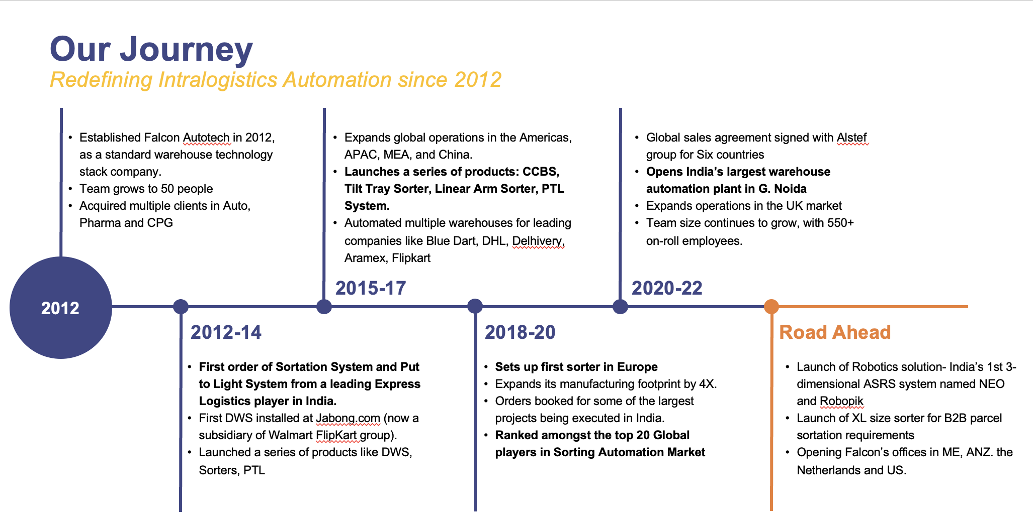
As a leading player in the intra-logistics automation space, Falcon continuously strives to improve the operational efficiencies and accuracies for its clients through its domain knowledge and experience in addition to its wide range of products and solutions. In order to be able to live up to the high expectations set forth by our clients, the team at Falcon realizes the importance of taking up selective applications in focused Industries and deliver world class projects in return.
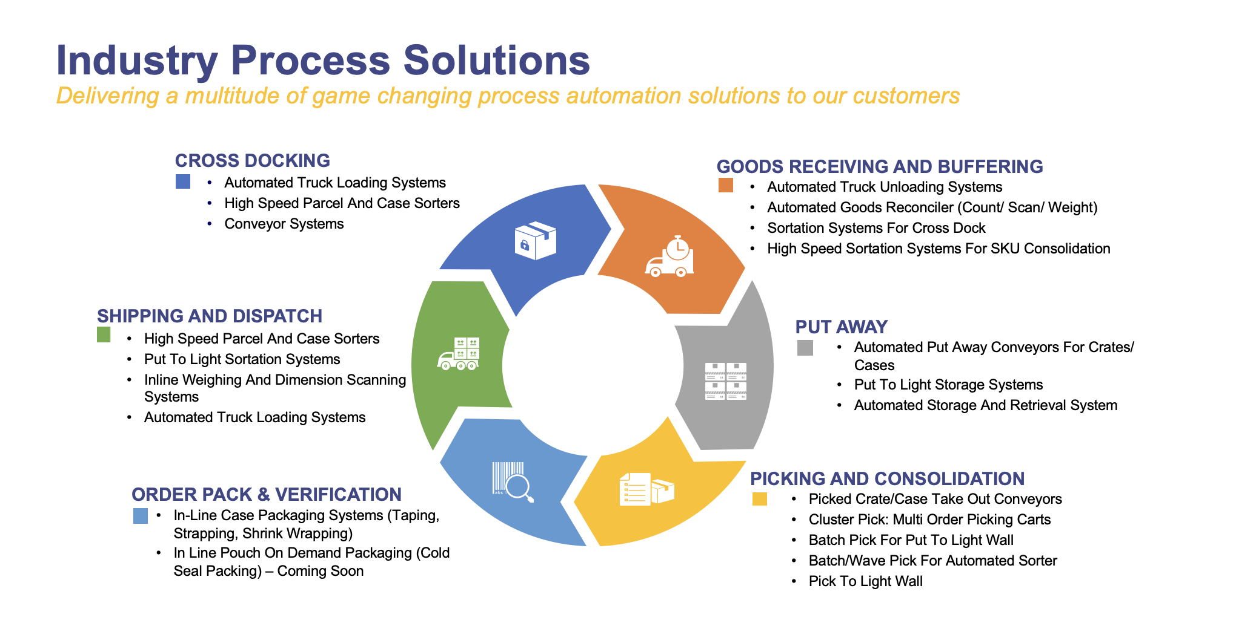

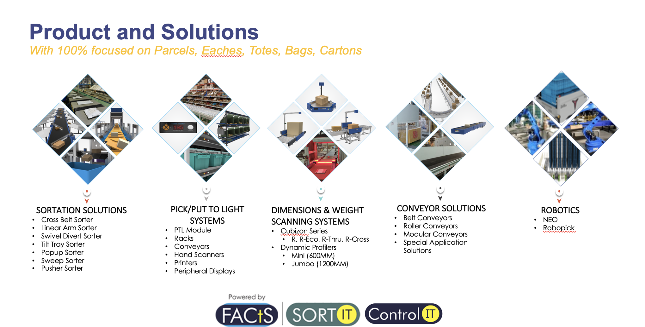
Falcon Autotech has successfully delivered warehouse automation solutions based on smart and innovative combinations of above product lines for effective materials handling, sortation and movement. The process is controlled in real-time by our in house WCS applications. These solutions considerably cut the need for manual operations, improve working conditions and ensure the highest accuracy of the entire process up to final delivery to the recipient.
Over the last 10 years, Falcon has worked with some of the most innovative brands worldwide and has established long standing partnerships. These brands are testimony of our strong focus on delivering superior customer satisfaction and offering end-to-end intralogistics solutions.
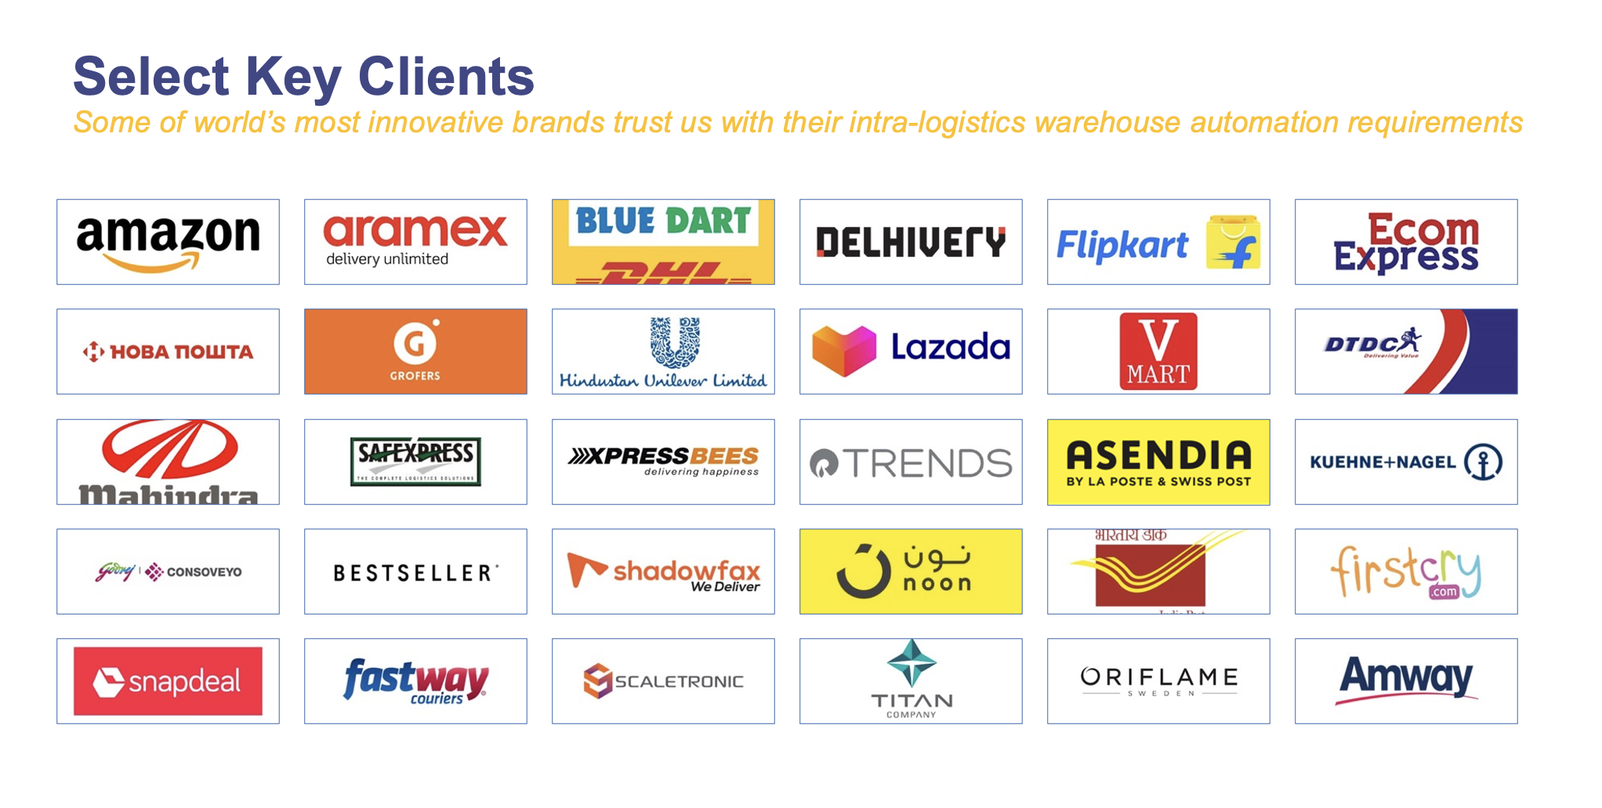

With over 1,800 installations, today Falcon’s systems are used all over the globe. Falcon has highly motivated team of 600+ employees supported by over 15 global partners who help us design, manufacture, deliver and maintain automation solutions globally.
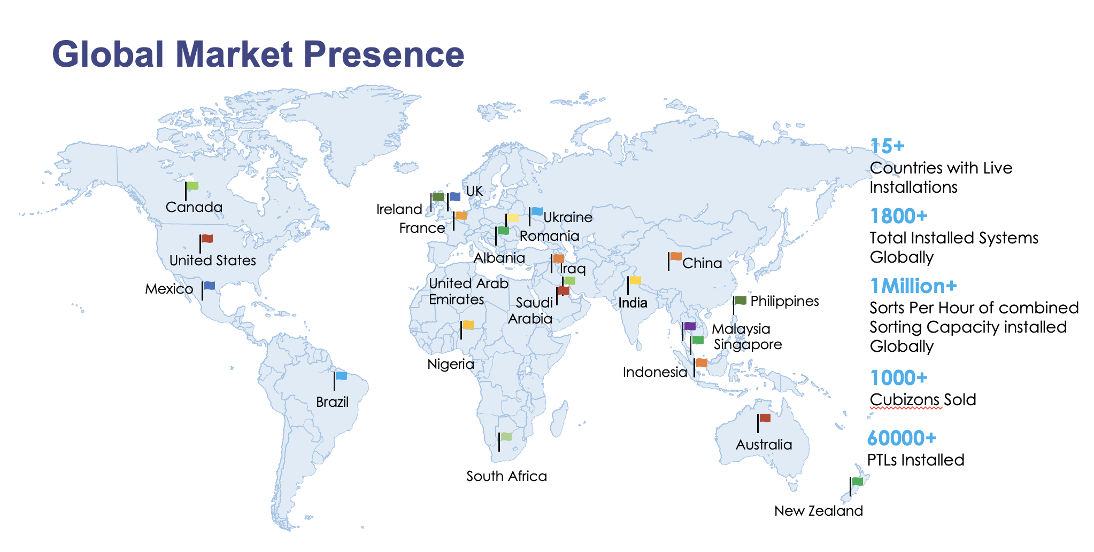

Falcon’s Experience and Achievements in Sortation Space Globally
- Ranked among Top 20 Sortation System Suppliers globally. Only company from APAC/EMEA Region.
- Currently possess one of the World’s largest portfolios in Sortation Technologies: 7 In-house technologies.
- Total installed capacity of 10 million Shipments per day worldwide.
- Only company to be able to offer a Fully Integrated AMS.

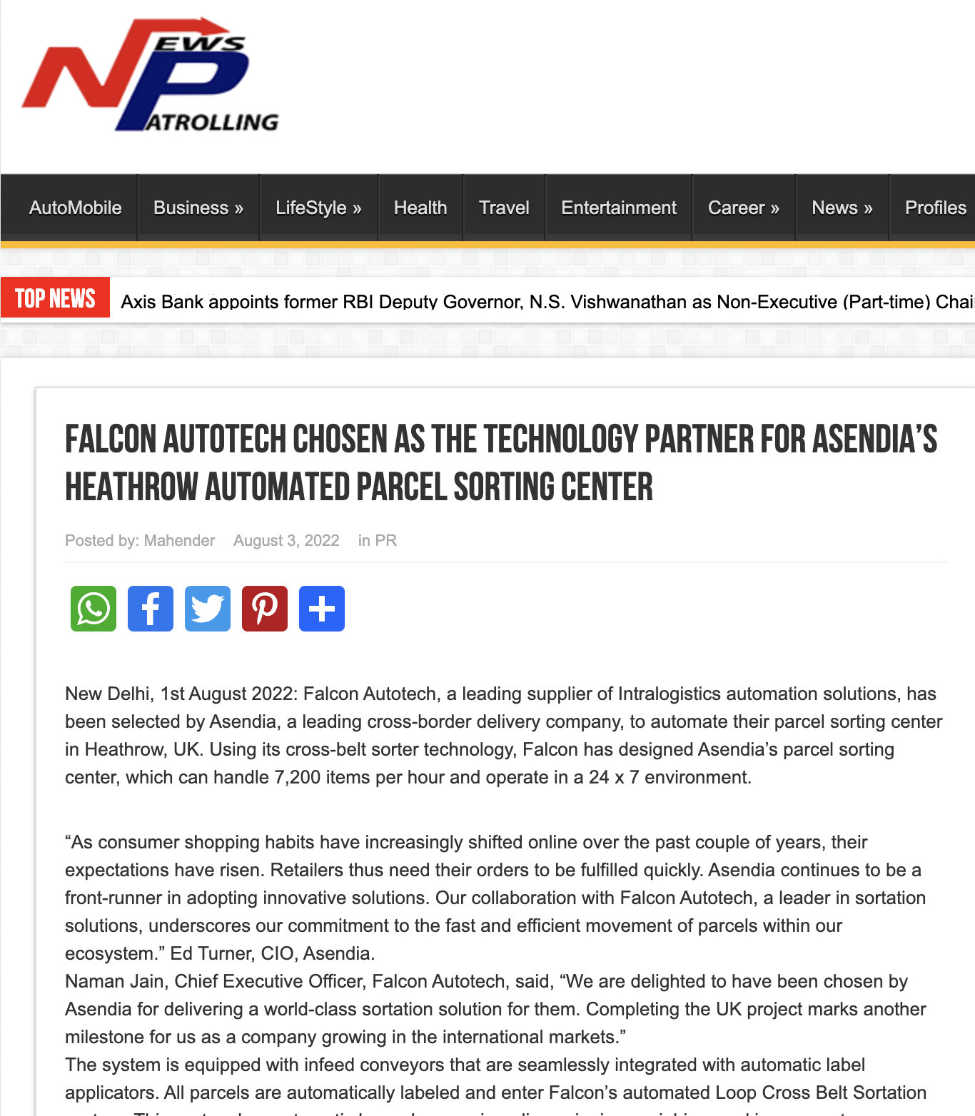




Reference Projects
Falcon has a strong legacy in Warehousing Automation solutions and references-

- Expertise in Shipment Sortation, Piece Picking and Handling, Case Picking and Handling.
- Lifecycle services (maintenance, spares supply chain, support).
- Full in-house expertise (Hardware/Software).
- Turn-key tailored solutions.
The references list presented below focusing on Sortation Solution –

Project 1- (CEP Client, UK)
This Solution is designed to handle a volume of 7200 shipments per hour. The system is equipped with three infeed conveyors integrated with automatic label applicator before shipments enter the sortation system. The shipments are sorted using Falcon's Linear Cross Belt Sorter equipped with automatic barcode scanning, dimensioning, weighing and image capture capabilities. The sorter is installed on the mezzanine floor and sorts directly to 58 end destinations.
Solution Specifications –
- Throughput: 7200 PPH
- End Destinations: 58 Nos
Key Technology Modules –
- Powered Belt Conveyors.
- Automatic Induct Lines.
- Automatic Barcode Scanner with Image Capture.
- Automatic Weight & Volume Measurement System.
- Linear Cross Belt Sorter.
- WCS Software System.
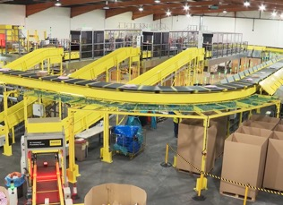
Site Picture –

Project 2- (CEP Client, Riyadh)
In 2019, customer selected Falcon Autotech as a preferred supplier for its airport hub to supply linear cross belt sorter for processing of shipments arriving via Air from different states and countries to distribute them locally. The customer chose Falcon Autotech based on its strong track record of success in providing intralogistics automation solutions, optimized design, software integration capabilities and life cycle support services.
Solution Specifications –
- Throughput: 4800 PPH
- End Destinations: 52 Nos
Key Technology Modules –
- Powered Belt Conveyors.
- Automatic Induct Lines.
- Automatic Barcode Scanner with Image Capture.
- Automatic Weight & Volume Measurement System.
- ARB Conveyor.
- Automatic Label Applicators.
- Linear Cross Belt Sorter.
- Specialized Chutes for Gentle Shipment handling.
- FOCR Engine.
- WCS Software System.
Site Picture –
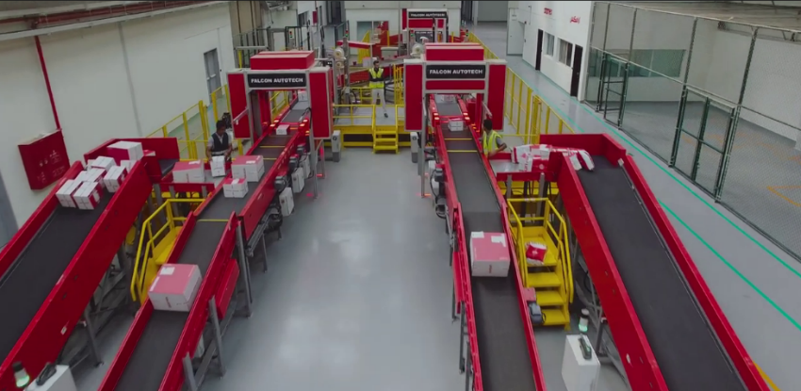

Project 3- (Client – Courier Express Shipment, Dubai & Jeddah)
This Solution is designed to handle the bulk volumes through Launchpads and induct them into Falcon's Linear Arm Sorter. This system is designed for a throughput of 3000 shipments per hour equipped with automatic barcode scanning, dimensioning, weighing and image capture capabilities to into a total of 480 end destinations with a combination of primary and secondary sortation system. The secondary sortation is achieved by integrating put to light system.
Solution Specifications –
- Throughput: 3000 PPH
- End Destinations: 480 Nos
Key Technology Modules –
- Powered Belt Conveyors.
- Linear arm sorter.
- Automatic Barcode Scanner.
- Automatic Weight & Volume Measurement System.
- WCS Software System.
Site Picture –
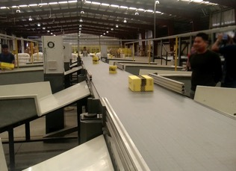

Project 4- (CEP Client, Sydney)
Solution is designed for handling a throughput of 16,000 shipments per hour with the help of Falcon’s Linear Cross Belt Sorter. The system consists of 2 feeding zones with a total of 10 feedlines. Sorter design enables the van drivers to directly drop the shipments at the dock doors. It has a total of 369 end destinations that are achieved with a combination of direct drops and PTLs. System is integrated with 5 side automatic barcode scanning, weight and volume measurement and automatic detection of oversize and overweight shipments.
Solution Specifications –
- Throughput: 16000 PPH
- End Destinations: 369 Nos
Key Technology Modules –
- Powered Belt Conveyors.
- 2 Induct zone.
- 5 side Automatic Barcode Scanner.
- Automatic Weight & Volume Measurement System.
- Automatic detection of oversize shipment.
- Linear Cross Belt Sorter.
- WCS Software System.
Site Picture –
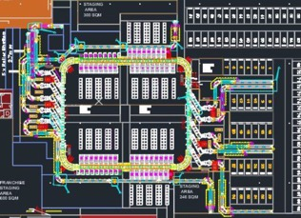

Project 5- (Client – E-Commerce, India)
Use Case – Destination Sorting of Packed Shipments.
In 2019, Client was looking for a potential automation partner for design and development of a new automated sortation system for B2C shipments. The system should be able to provide maximum uptime with reduced dependency on skilled manpower, and space optimization.
The customer chose Falcon Autotech based on its unique design which could cater to all their pain points, capability of seamless integration with WMS and life cycle support services.
Solution Specifications –
- Throughput: 27,600 PPH
- End Destinations: 410 Direct Outputs
- Building Size: 200,000 Sq Ft
Key Technology Modules –
- Bulk Infeed Conveyors.
- ARB based Volume Distribution System
- Integrated Presort System.
- Irregular Ejection System.
- Automatic Induct Lines.
- Automatic Barcode Scanner with Image Capture.
- Automatic Weight & Volume Measurement System.
- Linear Cross Belt Sorter.
- Smart Sliding Chutes for Direct bagging and Cage Sorting.
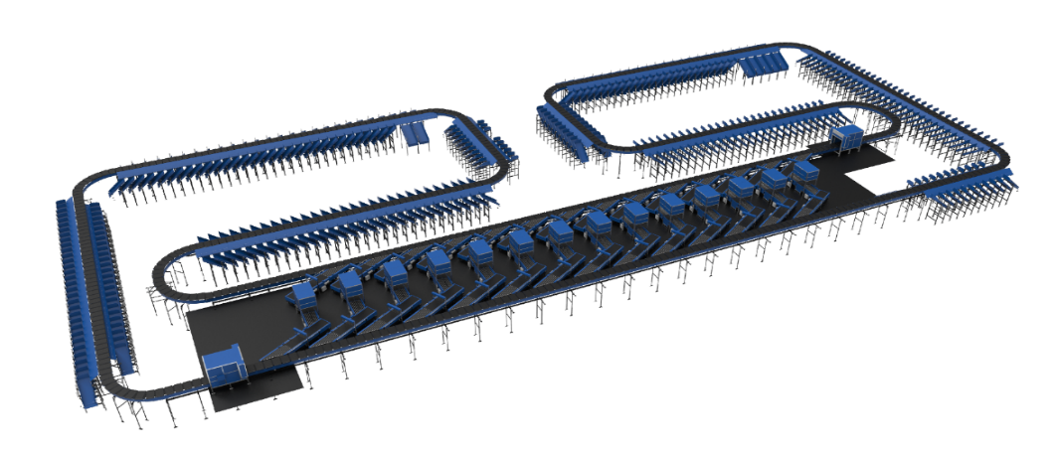
- Bag take out system
- WCS Software System.

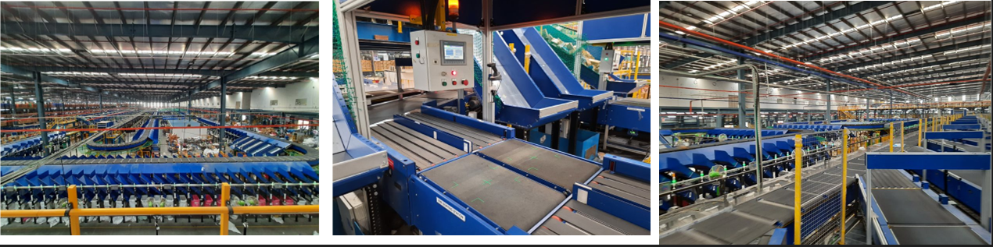

Project 6- (Ecommerce Client, India)
Use Case - Destination Sorting of Packed Shipments
Solution Specifications –
- Throughput: 24,000 PPH
- End Destinations: 110
- Building Size: 200,000 Sq. Ft
Key Technology Modules - Linear Cross Belt Sorter with a cell size of 900 x 500 mm
Layout and Site Pictures -
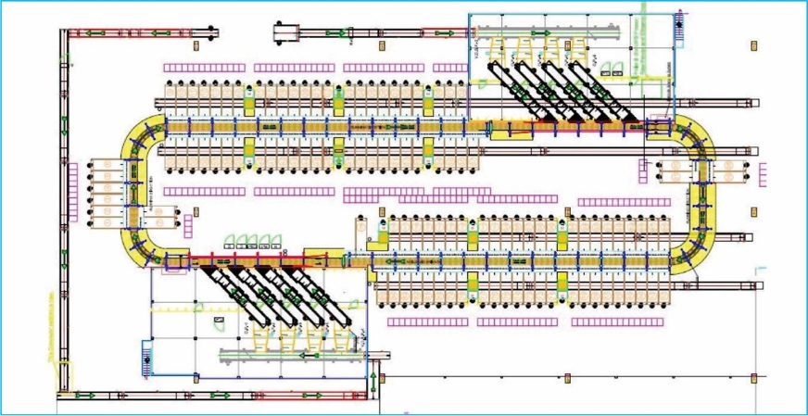

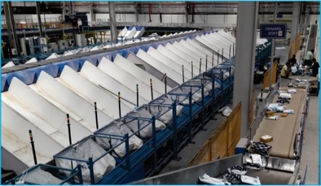
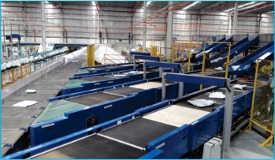

Handled Shipment Spectrum
As per the shipment spectrum data provided by Flipkart team, Falcon has studied and analysed the shipment spectrum in detailed.
Falcon purposes to use its “Linear Cross Belt Sorter” to provide the maximum benefits to Flipkart in-terms of handling variety of shipment sizes and weight.

Shipment size loadable on the sorter
Falcon’s Cross belt sorter has a capability to handle the shipments of below mentioned sizes and weight.

Specification | Unit | Value
Max Length | mm | 600
Max Width | mm | 400
Max Height | mm | 400
Max Weight | Kg | 10
Min length | mm | 100
Min Width | mm | 100
Min Height | mm | 50
Min Weight | gm | 200

Shipments to be loaded on Sorter shall have the following characteristics:

- Centre of Gravity of item must not move during conveyance or sorting.
- Item must not have magnetic content, otherwise behavior of shipment cannot be guaranteed.
- Liquid or fragile material, to avoid breaking, spillage or leakage, such as wine bottles, metal cans of paint are designated as non- conveyable items.
- Shipments shall be perfectly and safely packaged: protrusion or open surfaces are not allowed.
- Plastic ropes shall be perfectly adherent to the surface of the package.
- All items with the risk of being damaged during the transport on an automatic sorting system or
damaging the sorting system. They must be robust enough to avoid disintegration of container material and loose of contents in the sorting process.
- Item packaging shall have enough grip to be handled on the belts during the acceleration and
referencing phases.
- Items shall not have slippery surfaces and must be able to withstand acceleration of the items on the belt during the start-stop phases (accelerations up to 0.5 g shall be assured without any sliding or tumbling of the items on the belt conveyor).
- The shipments must have at least one flat and regular surface providing enough stability during conveyance.
- All shapes are permitted except spherical, cylindrical, or alike unstable items & shapes.
- All usual packaging materials are permitted (including paper, carton, plastics, plastic foil, rope, tape, textile, and wood)

Shipment not loadable on the sorter

All products that are not within the range as described here, are considered non- conveyable products, and must be taken out of the main sorter flow by the operators.

- Unstable items with a risk to roll or tumble on the sorting system, such as spherical or cylindrical items.
- Items that have a spherical or cylindrical shape.
- Items that are packed in material that can damage the conveyors or the sorter.
- Items that have sharp points (e.g., Nails) or sharp edges, that can damage the conveyors or the sorter.
- Fragile shipments with contents not sufficiently secured.
- Items that have been classified as dangerous are designated.
- Wet items are designated.
- Items with anti-slip treatment.
- Items with protruding parts.
- Items with sharp edges.
- Inadequately packed items that could be damaged during automatic transportation.
- Electrostatically loaded items.
- Loose parts on loads and load carriers, such as adhesive tape, stickers, slips of paper, straps, wrap foil etc. are designated as non- conveyable items.

Pictures of Sortable Shipments
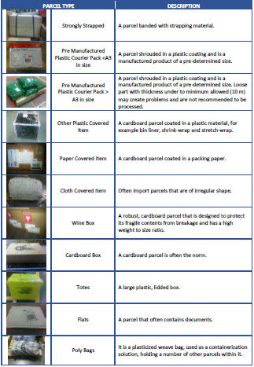

Proposed System Description

Objective
The purpose of this proposal is to present the design, manufacturing, installation, commissioning, testing, and acceptance testing of the Linear CBS for sorting shipments as per Flipkart’s logic.

Summary of the System
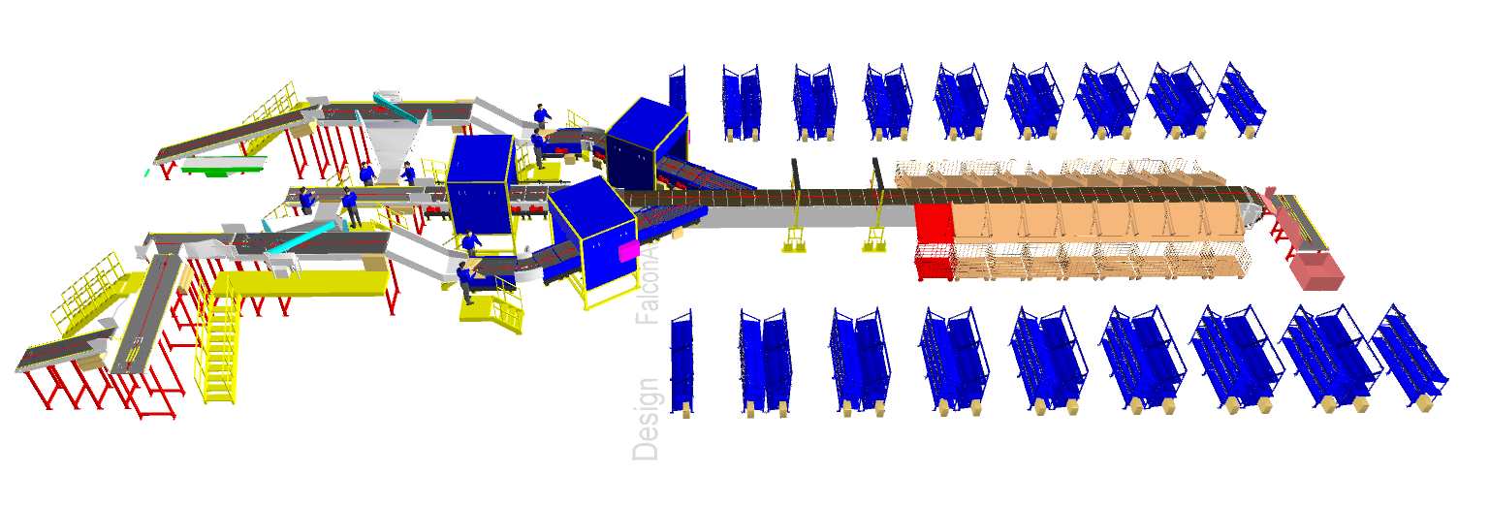

Process flow of the Linear CBS System-
- Infeed System: - The integrated Conveyor Connection will take the volume coming from packing lines & ascend it to VDS level.
- Volume Distribution System:- The Arm based VDS will divert sufficient amount of shipments in each chute, so all of the operator get enough shipment to match the given IPP.
- Inducts: - Upon arrival at the VDS chute, An operator pick & place the shipment with barcode facing top side. After which the weight data, Volume data & barcode data is captured & Falcon's automatic induct lines accurately and smoothly inducts the parcels onto the Linear CBS, based on their dimensions and weight.
- Linear CBS: - Once the parcels enter the main Linear CBS the CBS sorts shipments efficiently into their designated output chutes using data provided by Flipkart.
- Output Chutes: - The shipment are discharged into below output chutes.
  - Collection Chutes – There are 17 transfer chute with end flap to enable the collection of shipment when required.
  - Sortfail – A conveyor integrated chute is designed to collect and gradually disperse the parcels those failed to sort in their designated output chutes.
  - Rejection Chute- One collection type chute handles rejected shipments.

Main benefits of the proposed solution
The proposed solution has the following advantages:

- High proven operational throughput
- Good Shipment conveying quality for the entire range of conveyable Shipments with a sorting speed of up to 1.5 m/s.
- Low occupancy of floor space in the building.
- Narrow discharge centers for the increased number of splits in limited space
- FALCON’s CBS can adapt to changing business requirements by adjusting its speed
to match the operational throughput requirement, thereby leading to Power Savings
and reduced system Wear & Tear.

Concept Description
Pack Line Conveyors (Existing)

Volume Distribution System

Induct lines

Linear CBS
Collection Chutes
Rejection Chutes
Sortfail Chutes

Layout View
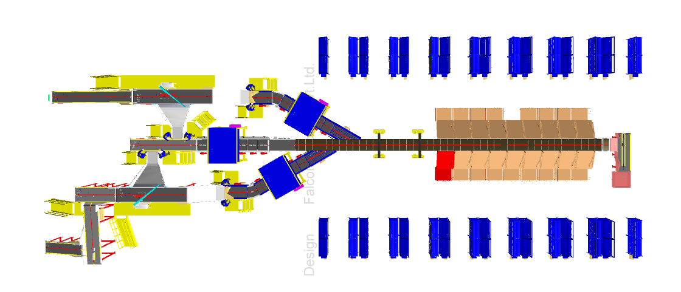

10

4
2
1
5
7
9
6
5
3
5
7

8

4
2
10

1

Legend
1 – Infeed Conveyor
2 – Volume Distribution System
3 – Top Loading Induct line 6K
4 – Side merge Induct 3K
5 – Scanning, Dimensioning & weighing Tunnel
6 – Main Linear CBS
7 – Collection chutes with end flap
8 – Rejection Chute
9 – Sortfail Chute
10 – Secondary Sortation (In Flipkart’s Scope)

Proposed System Capacity Calculations

Sorter System Capacity
The following table shows the throughput calculation for the sortation system designed based on Flipkart requirements.

SPECIFICATION | VALUE
Sorter Type | Linear CBS
Speed | 1.5 m/s
Pitch | 500 mm
Carrier per hour | 10,800 CPH
Belts per hour | 10,800 BPH
Designed Throughput of 1 Linear CBS (A) | 10,800 shipments per hour
Top Loader Feedline Capacity | 6,000 Shipments per hour
Side Merge Feedline Capacity | 3,000 Shipments per hour
No of Feedlines | 3 Nos.
Total Feedline designed capacity (B) | 12,000 Shipments per hour
System designed throughput (Lower of A&B) | 10,800 Shipments per hour

System description

Infeed System
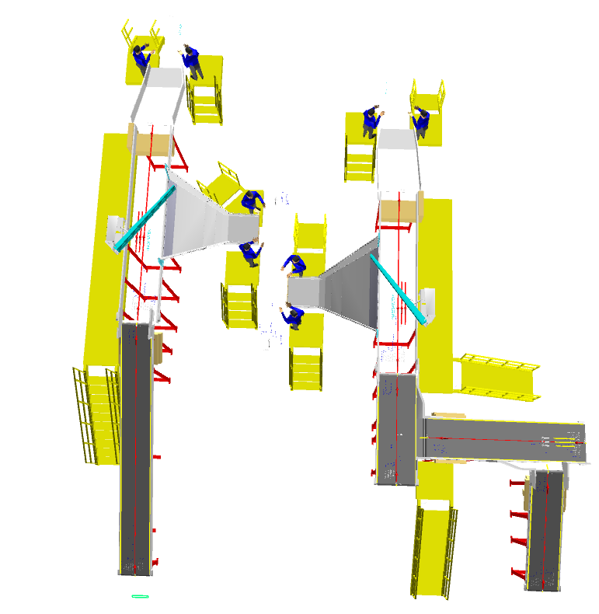
5
5

5
5
4
3

2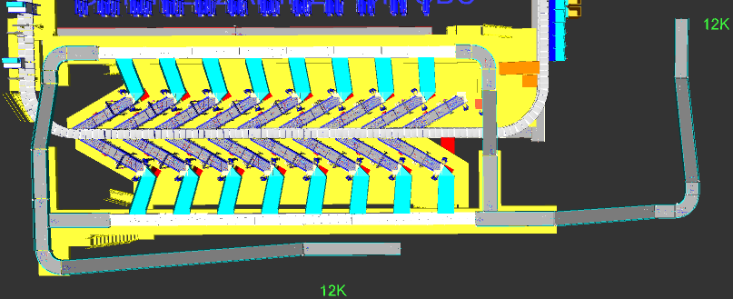
1
1

The system is equipped with three infeed conveyors, facilitating the movement of shipments from the lower level to the mezzanine level.
Legend
- Inclined PVC Belt Conveyor
- Straight PVC Belt Conveyor
- Straight Modular conveyor
- XL Arm Diverter
- VDS Chutes

Infeed System
Infeed conveyor system consists of below components:
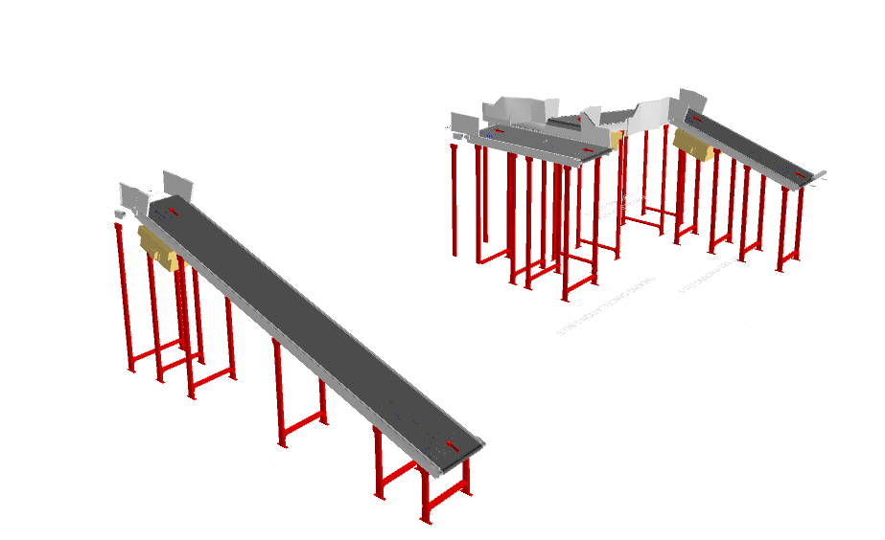
- Straight Belt Conveyor
- Inclined PVC Conveyor

Straight and Inclined Powered Belt Conveyor

Falcon’s Belt Conveyors are modular & robust in design, used for smooth conveying of products over Straight, inclined and declined paths. MS profile is used to build conveyor frame.

The conveyors are supplied with the necessary supports and bolts to fix them to the supporting plane, as well as with the junction elements allowing easy and jam-free passage from one conveyor to the other.
Some Silent Features of Falcon’s Belt conveyor:
- Low Noise
- Maximum uptime.
- Minimal maintenance
- High safety standards.
- Fastest ROI.
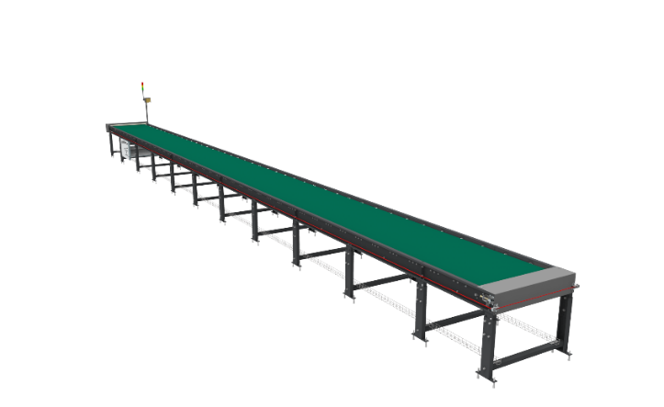

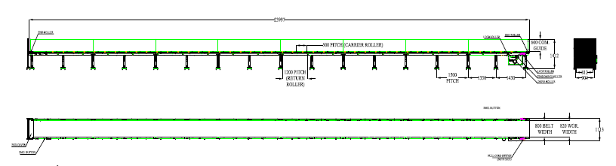

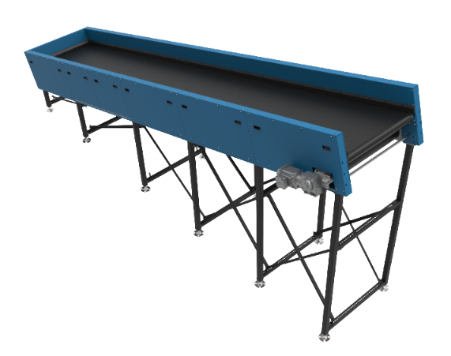
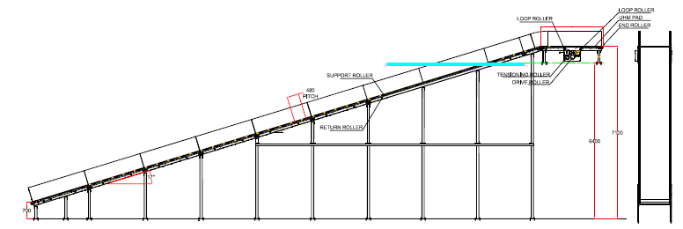

Specification | UOM | Remark
Manufacturer Name | Name | Falcon Autotech
Material of Roller | Type | MS Rollers with Zinc Plating
MOC of Belt | Type | PVC
Belt Thickness | mm | 3
Belt Finish | Type | Matt Finish
Belt width | mm | 800
Belt Joint Type | Type | Vulcanized, Endless Belts
Belt Make/Model No. | Make | FORBO/DERCO
Chassis | mm | MS, 3mm Thick, Powder Coated-75 Microns
Idler Roller Pitch on running side (Top) | mm | 480
Idler Roller Specs | Spec | Dia.50.8, shaft-12 mm, bearing-6301
End Rollers | Spec | Dia 81.2 x 2.85 Thick, 30mm Shaft Dia, & Bearing Size-UCFH206D1, MOC-EN9, Zinc Plated -25 microns
Drive Rollers | Spec | OUTER Dia 178 PIPE Dia 168x5 Thick, 40mm Shaft Dia, & Bearing Size-UCF208D1, MOC(SHAFT)-EN9, NEOPRENE RUBBER COATING
Motor Shaft | MOC | EN9 Shaft material
Conveyor Under guarding | Spec | MOC-MS, 0.8 to 1mm thickness, Steel Stiffeners at every 600mm to avoid the sagging due to self-weight
Load capacity per unit length of Conveyor | kg/m | 50
Type of Guides | Type | Steel guides at 50mm/400mm height basis the position of conveyor on both sides from Conveyor Belt Surface.
Drive Power Rating | kW | Motor Rating depends on Length of the Conveyor
Type of Motor | Type | AC Geared Motor
Ingress Protection | Type | IP 55
Type of Drive System | Type | Direct Shaft Mounted Motor/ Flange Mounted
Type of Drive | Type | Chain drive/Torque Arm type
Gear Motor | make | Sew/Nord
Drive | make | Lenze/Siemens/Omron/Allen Bradly
Insulation Class | Type | Yes
Conveyor Speed | m/s | Variable speed to meet TPH requirements
Type of Mounts | Type | Fixed Heights Legs with Grouting Provisions

Conveyor BOQ

S No. | Name | ANGLE | EL_1 | EL_2 | Length (m) | Width (mm) | Set
1 | PVC Belt Conveyor | 18 | 1980 | 2974 | 3.2 | 810 | 1
2 | PVC Belt Conveyor | 18 | 900 | 3077 | 7.0 | 810 | 1
3 | PVC Belt Conveyor | 8.2 | 2647 | 3270 | 4.3 | 1010 | 1
4 | PVC Belt Conveyor (S3) | 0 | 3000 | 3000 | 2.8 | 1010 | 1
5 | PVC Belt Conveyor (S3) | 0 | NA | NA | 2.8 | 1010 | 1

Induction to Sorter

The main purpose of the feedlines is to receive the Tote/Boxes from the infeed highway lines & induct it Smoothly & accurately onto the sorter by means of receiving conveyors, Weighing, Buffer/Spacing Conveyor and Angle Merge conveyors.
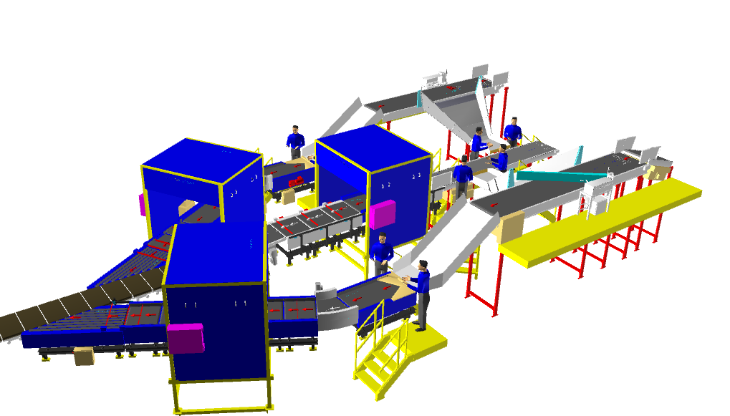
Weighing Scales installed on the feedlines will capture the weight of each shipment and will perform weight control to detect out-of-spectrum shipments.
The system's design ensures that the maximum capacity of each feed, considered as the sum of the flows from the connected inductions.

Induction Lines

Feedlines
Linear CBS has three Automatic Feedlines with Designed IPP of 3000 PPH for Side inducts & 6000 PPH for top loader.

Each Feedline side induct has 8 Conveyor Modules-
  - Weighing Conveyor- 1 Nos.
  - Loading Conveyor- 1 Nos.
  - Spacing Conveyor- 2 Nos.
  - Buffer conveyor- 2 Nos.
  - Angle Merge- 1 Nos.
  - 30 deg turn

Top Loader induct has 8 Conveyor modules
  - Weighing Conveyor- 1 Nos.
  - Loading Conveyor- 1 Nos.
  - Spacing Conveyor- 3 Nos.
  - Buffer conveyor- 2 Nos.
  - Top loader Conveyor- 1 Nos

- Sensors are placed on the Induct Lines to determine the exact position and dimensions (Length and Width) of the Shipment on the conveyor and prepare the Cross-Belt Cell for receiving the shipment with high precision.
- Over the feedline, shipments are evenly spaced and smoothly transferred to the main Linear CBS.

Weighing Conveyor
A weighing conveyor, also known as a weigh belt conveyor, is a type of conveyor system specifically designed to measure the weight of materials as they move along the conveyor belt. It combines the functions of conveying and weighing into a single integrated process.
Weighing Conveyors equipped with high precision Load Cells to capture the weight of Shipments.
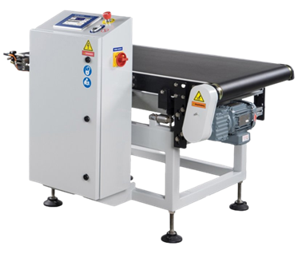
Make- Bizerba/ Mettler Toledo

Receiving Conveyor
A Receiving conveyor is a type of conveyor system used to receive & Release the products for induction onto CBS. It serves as the connection point at turn point of entry where products are collected and conveyed to subsequent stages of the process.
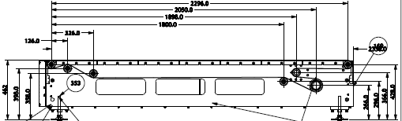

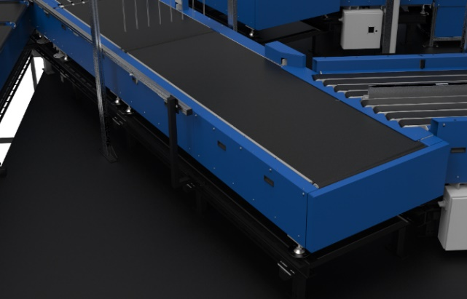

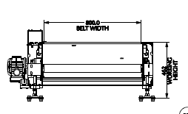

Buffer Conveyors
A buffer conveyor, also known as a buffering conveyor or accumulation conveyor, is a type of conveyor system used to temporarily store or hold items in a controlled manner. Its primary purpose is to manage the flow of items between different stages of a production or handling process when there is a mismatch in the speeds or capacities of the upstream and downstream equipment.
This Conveyors required to maintain the Throughput of Line.
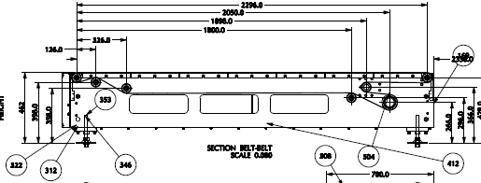
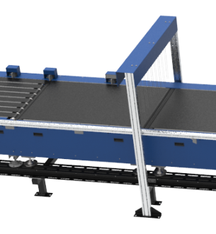

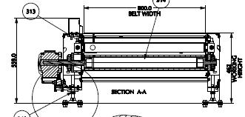

Powered Belt Merges & ZTR Curves (Pic for ref.)
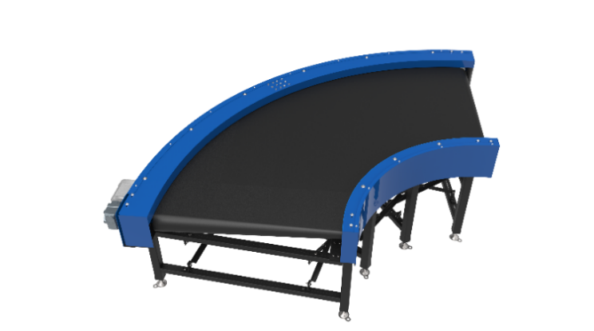
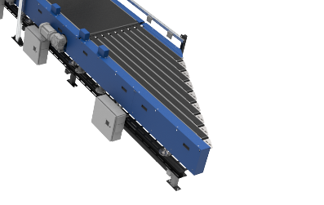

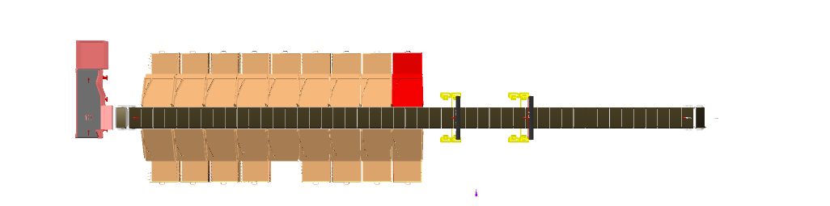
Linear Sorter
Induct Zone

- The proposed Linear CBS Sorter will be installed on ground level. The Sorter runs at 1700 mm from ground level.

- We have provided Linear with single belt Carriers with 500 mm pitch and Belt Size of 101 x 800mm.

- One Linear CBS has a top running length of 23.58 m & a total length of 47.5 m & 329 number of carriers.

- As Parcel pass through the Barcode Scanning Tunnel on the induct line, their barcodes are scanned, and chutes are assigned. Once the Parcel reaches the respective chute, the carrier carrying the Parcel for the chute will actuate and drop the Parcel in the assigned chute.

Sorting Output

Collection Chute
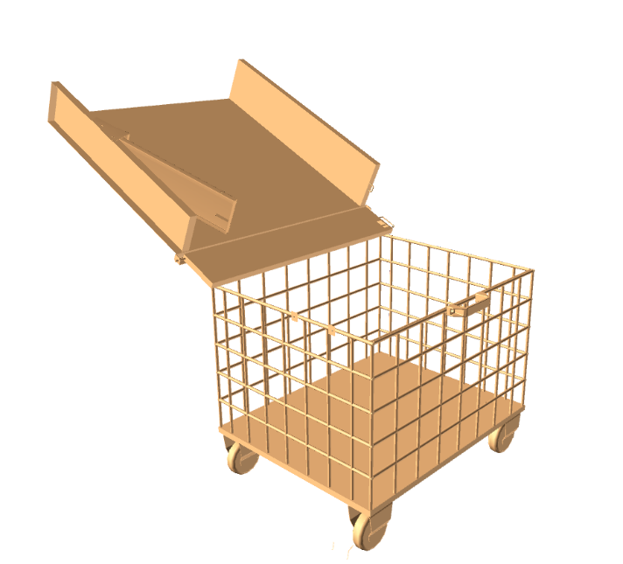
A collection chute is a type of chute used for the smooth descent of materials or objects from an elevated position to a lower level. It utilizes its roller platform to gradually descend & collect the parcel at the end of the.

Cart’s Image for representation purpose only

Calculation for Design: We have considered an average shipment size of 400 X 400 X 400 mm while designing the capacity of chutes.
Average shipment size considered for chute volume calculation | L(m) | B(m) | H(m) | Volume (m3)
 | 0.25 | 0.25 | 0.25 | 0.015
Collection type chute | 1.2 | 1.2 | 0.3 | 0.432

Volume Wise - Assuming a 100% occupancy rate, about 28 Parcel will readily fit into these chutes.
Each Chute is equipped with below components to ease the operations:
- Chute Full Sensors
- Three Color Tower Light
- Push Button
Chute I/Os | Description
Chute Full Sensor | To alert the system that the chute is full and mark that chute unavailable for further sortation
Three Colour Tower Lamp | To indicate the chute status
Push Button | To Start/Stop Sorting Operations

Rejection Chute
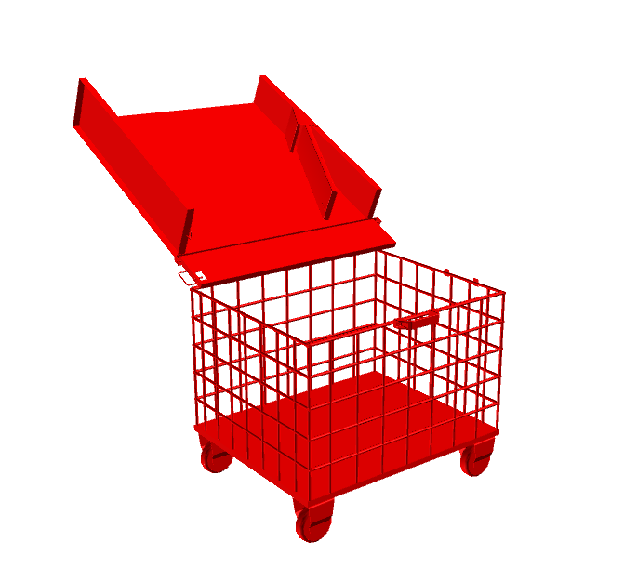
A Rejection chute is a type of chute used for the smooth descent of materials or objects from an elevated position to a lower level. It utilizes its roller platform to gradually descend & collect the parcel at the end of the.

Cart’s Image for representation purpose only

Calculation for Design: We have considered an average shipment size of 400 X 400 X 400 mm while designing the capacity of chutes.
Average shipment size considered for chute volume calculation | L(m) | B(m) | H(m) | Volume (m3)
 | 0.25 | 0.25 | 0.25 | 0.015
Collection type chute | 1.2 | 1.2 | 0.3 | 0.432

Volume Wise - Assuming a 100% occupancy rate, about 28 Parcel will readily fit into these chutes.
Each Chute is equipped with below components to ease the operations:
- Chute Full Sensors
- Three Color Tower Light
- Push Button
Chute I/Os | Description
Chute Full Sensor | To alert the system that the chute is full and mark that chute unavailable for further sortation
Three Colour Tower Lamp | To indicate the chute status
Push Button | To Start/Stop Sorting Operations

Sortfail Chute
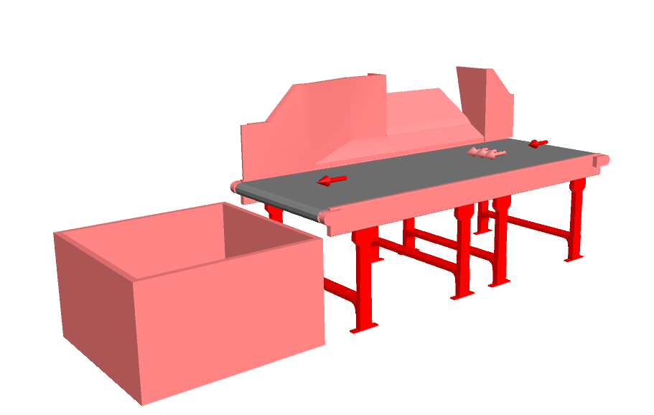
A Sortfail chute is a type of chute used for collection of parcel which failed get sorted in there respective chutes & also makes sure that the parcels doesn’t get accumulated near CBS edge resulting smooth operation of CBS..

Cart’s Image for representation purpose only

Description of Components of Equipment

Elements of the sorting system
- Cross Belt Sorter
- Scanning & Sensing on Sorter
- Conveyor System
- Steel Works- Mezzanine & Staircases

Cross Belt Sorter -

Cross Belt Sorter is capable of sorting extremely high volume of versatile products in a gentle manner.
Falcon’s Cross belt sorter is powered by high efficiency linear motors and is based on 100% non-touch actuation technology leading throughput capabilities with extremely low noise levels.
Falcon’s Cross belt sorter is modular in design. It can be easily extendable as per future requirements


CBS Carrier

Falcon Autotech’s CBS offers one of the highest Belt widths to Carrier Pitch Ratio in the market today. This additional belt width makes the system capable of handling larger product sizes without compromising on throughput. This also means reduced “dead area” between Carrier belts which drastically reduces the amount of “inbetweeners “and non-sortable shipment recirculation.

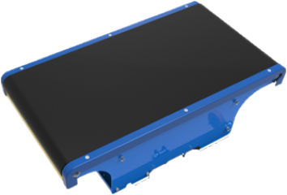

Servo Roller

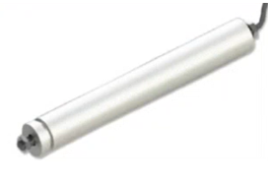
High Powered DC Drive Servo Roller are used to actuate the carrier belts, thereby eliminating the need for complicated drive transfer mechanism, and simplifying the system installation and maintenance.

Chassis

Falcon Autotech’s Cross Belt Carrier Chassis is made up of lightweight Aluminium which makes them light yet sturdy. This reduced weight leads to substantial “Power Savings” over a considerable period of usage.

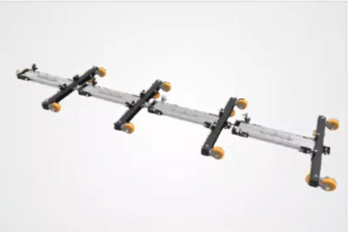

Carrier Wheels

Carrier wheels that are thoroughly tested and proved for long life cycle.
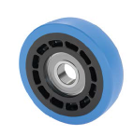

Non-contact based linear motor drive
Extremely High Energy Efficient Linear Synchronous Motors that can be configured at variable speeds depending upon the operational requirements giving you the maximum flexibility when needed.
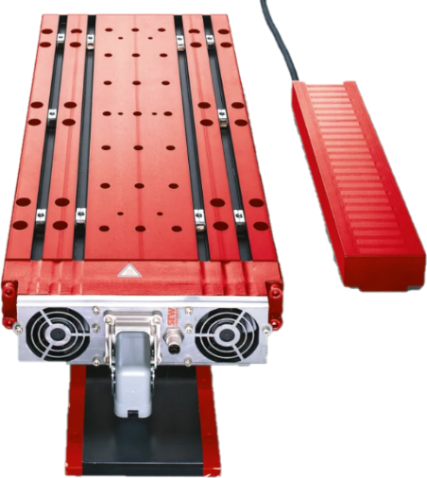

Power Transmission
Power transmission to Carriers over sliding contacts that require low maintenance and offer high levels of reliability.
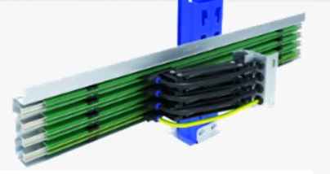

Data Transmission
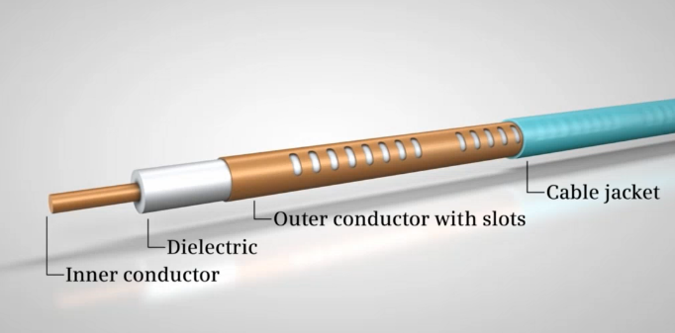
The R-Coax cable is used for data distribution in the sorter. This is a leaky wave cable, that runs throughout the sorter length transmitting the data. There is one antenna present in the super master carriage, which keeps on receiving the signal from this cable while on the move, wirelessly.
Leaky wave cable position
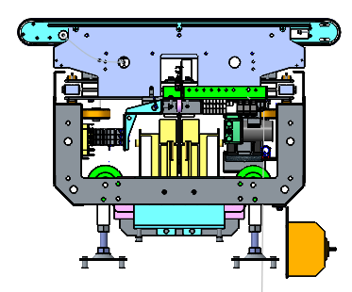

Carriers positioning System.
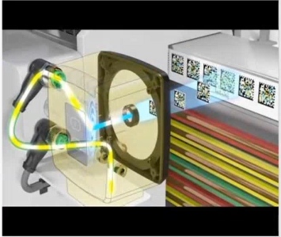
Positioning system determines the exact location of each carrier in the Linear at any given point in time. There is a plastic tape strip of barcodes (QR Codes) that is running along the sorter Linear, which is continuously scanned by scanners placed on a Carrier (Master Carrier)

Technical specifications of Sorter

Items | Make
Sorter Carrier Type | Linear CBS
Sorter Speed in m/s | Up to 1.5 m/s
Sorter Linear Length (Top Side Only) | ~23.5 m
Sorter Actuation Technology | Electric
Chutes
Collection Chute | 17
Rejection Chute | 1
Sort fail Chute | 1
Height of Sorter | ~1700 mm
Carrier Design
Carrier Motor Make | Falcon
Carrier Pitch - mm | 500
No. of Carriers | 101 Nos.
Drives
Motor/Drive type | Linear Synchronous Motor
Power Consumption | Will be specified during DAP
Feedlines (Fully Automatic) | 03 Nos
Power and Data Transmission
Power Transmission | Over Continuous Bus Bar
Maintenance Speed of the Sorter- Jog Mode | 0.8 m/s
Area Requirement (L x B) | Refer Layout

Scanning & Sensing on Linear Sorter

Automatic Barcode Scanning
Top Sided Barcode Scanner to scan shipment 1D codes and 2D codes. The Scanner is also capable of Archiving Shipment Images in Real time. As per FLIPKART requirements, Scanning is in FLIPKART scope.
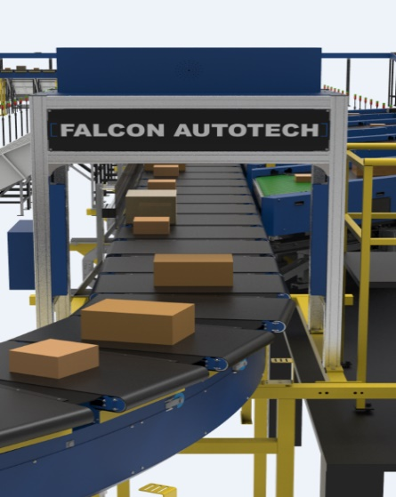

Shipment Positioning System.
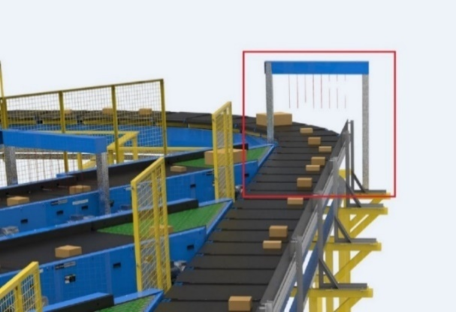
Falcon Cross Belt Sorter is equipped with Multiple shipment positioning Scan Tunnels. A tunnel comprises of a series of high Precision Laser Scanners that detect the absolute position of the Shipment on the Cross-Belt Carrier and prepares the Carrier for discharging the product accurately into the chute (virtual centring) and physically bring the product to the centre of cross belt carrier (Physical centring).

Steel Works – Mezzanine & Staircases- (In Flipkart’s Scope)

Operator Platform & Maintenance Platform

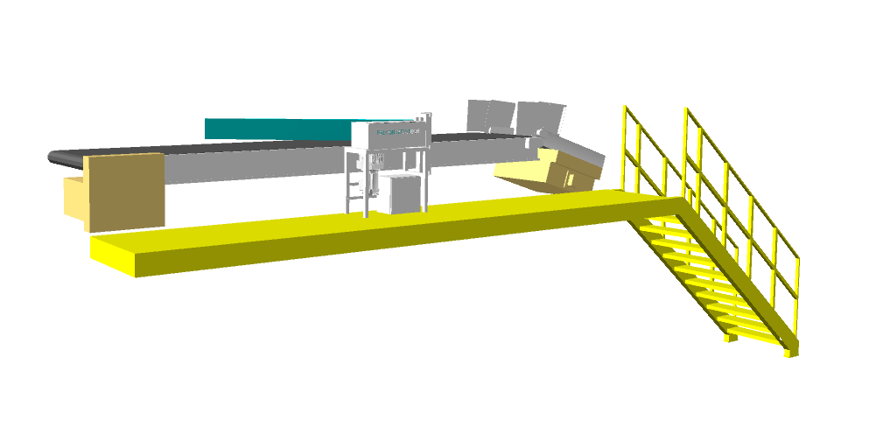
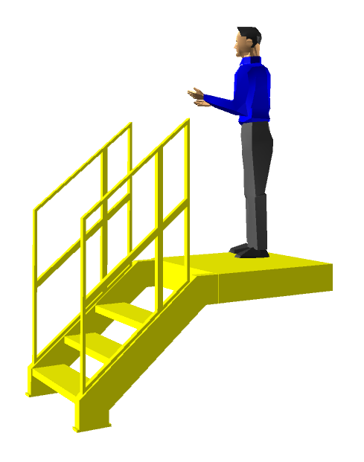

- Total 8 Platform for operator with 1 Sqm each
- There are three maintenance platform with overall area of 13.4 Sqm
- No of Stairs for operator platform: 8 Nos
- No of stairs for maintenance platform.

Proposed System Technical Details

Mechanical equipment
Pos. | Qty. | Description | Value
1 | 1 | Infeed System  - Powered Belt Conveyors | ~20 metres (05 Modules)
2 | 1 | Volume Distribution System  - Modular Conveyor  - Arm Diverter | ~10.8 meters (02 Modules)  02 Nos
3 | 3 | Feedlines  Each 3K induct Consists of  - Loading Conveyor  - Buffer Conveyor  - Spacing Conveyor  - Weighing Conveyor  - Angle Merge  - 30 deg Turn  Top Loader  - Loading Conveyor  - Buffer Conveyor  - Spacing Conveyor  - Weighing Conveyor  - Top Loader | 1 Set  2 Set  2 Set  1 Set  2 Set  1 Set  1 Set  2 Set  3 Set  1 Set  1 Set
4 | 1 | Sorter  1 Linear Cross Belt Sorter  - Sorter Height  - Sorter Length  - Sorter Speed  - Sorter Drive  - Carrier Pitch  Including:  - Standard Sorter Supports | 1700mm (from mezz level)  ~23.58 m (Top Side)  ~1.5 m/s  Linear Synchronous Motor  500 mm
5 | 1 | Sorter Outputs  - Collection Chute  - Rejection Chute  - Sort fail Chute | 17 Nos  20 Nos  01 Nos
7 | 1 | Steel Works (In Flipkart’s Scope)  - Operator Platform  - Maintenance Platform  - Stairs | 1 SQM X 8 Nos  ~13.4 SQM  11 Nos

Electrical Equipment

Electricals
1 | 1 | Consists of  Main Power Distribution panel  Main Control Panel  Feedline Control Panels  Sorter Drive Panels  Network Switches  Field Cabling | Included

Control System

Components
1 | 1 | Consists of  Omron PLC based Control System with SCADA  Industrial Switch | 1 Nos.  As per requirement

Electrical System
Main power supply will supply Falcon’s PDP (Power Distribution Panels) electrical cabinets.
PDP cabinets supply the entire system via secondary cabinets:
- Main Control Cabinet
- Induct Control Panels
- Remote Cabinets for Sorter I/O
- Scanner Control cabinets

Reference Picture of Power Distribution Panel
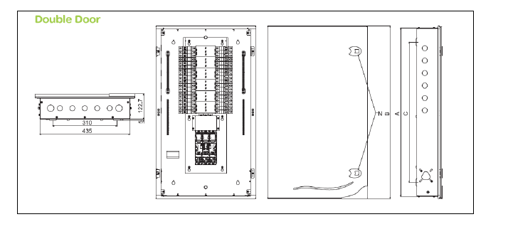

Main Control Panel (Reference)

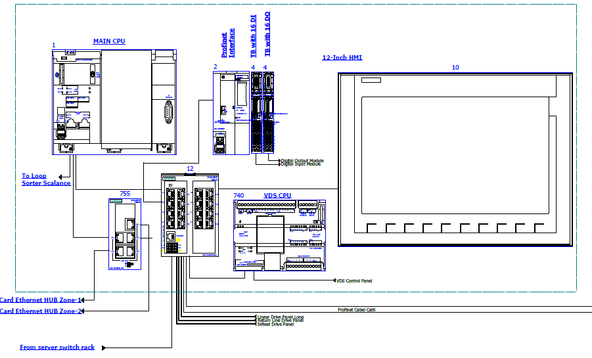

Induct Stations Control Panel (Reference)

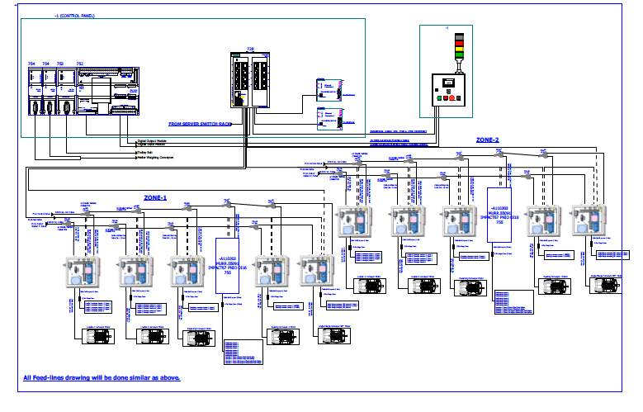

Engines
Three-phase alternating current motors (Induction) will be used through a frequency converter.
The engines will be coupled with a converter to improve consumption and reduce the carbon footprint.
All motors will have appropriate IP ratings

Sensors
The sensors will be supplied, standardized by type, with connector, with a cable length suitable for easy extraction, suitably protected from possible impacts.

Control command
The proposed solution is based on SIEMENS Programmable Logic Controller technology (PLC) platform. The entire system will be logically divided into Zones (Sorter/ Feed Line/ Linear), each managed by a PLC. The planned primary communication protocol is going to be ProfiNet.

Conveyor interface
The frequency converter of each conveyor allows the acquisition of the signals of the sensors/actuators/GIOs associated with it (e.g. conveyor end detection photocells, blockage detection photocells). Each frequency converter will be connected in series by means of the ProfiNet field bus

Controls Architecture (Ref.)

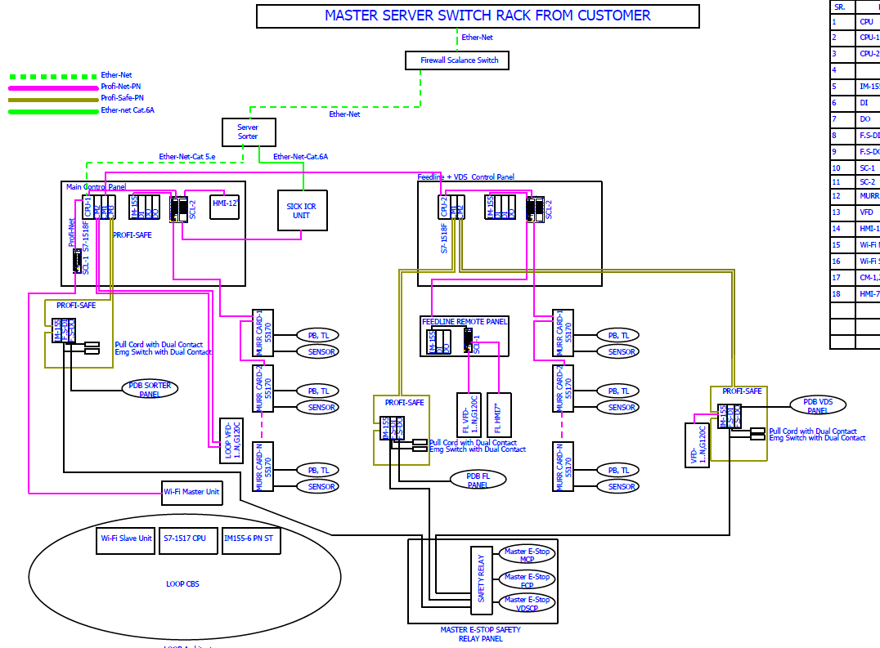

IT Architecture (Ref.)
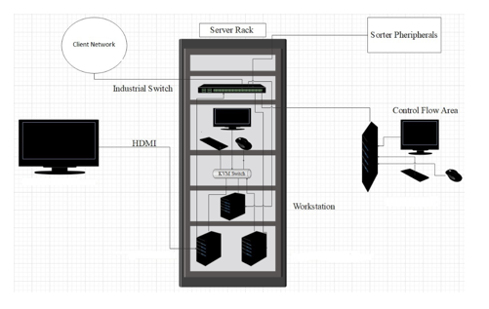

HAA Server (In Flipkart Scope)

S.no | Description | Qty
20Core Config with 128 GB RAM in T440 and 64 GB RAM in T40
1 | Synology_storage_DS723+ 2.6 GHz AMD Ryzen R1600 Dual-Core, 2 x Gigabit Ethernet Ports, | 2
 | 2GB ECC DDR4 RAM, 2 x 3.5/2.5" Bays | 2 x M.2 2280 Slots E10G22-T1-Mini 10GbE RJ-45 network upgrade module for compact Synology servers
2 | Dell Tower Model T440 -PowerEdge T440 Xeon Gold 6148 2.4GHz/20C/27.5MB/150 W 16 DIMMS 4 x32GB RDIMM Up to 8 3.5"" Hot Plug Hard Drives Tower Configuration 2 x 1.2TB 10K RPM SAS 12Gbps 512n 2.5in | 2
 | Hot-plug Hard Drive PERC H750 Adapter Full Height 8GB Cache Dual Hot-plug PS495W iDRAC9Enterprise 3YR ProSupport Next Business Day Onsite/Dual Port Lan
3 | Dell PowerEdge T40 Intel Xeon E-2224G Processor 3.5GHz 8M Cache,4C/4T,Turbo,71W,TPM, 4*16 GB RAM (4 DIMM), 2x1TB SATA 3.5" 7.2k rpm HDD (3 Bay), 1Gbe LOM ,DVD Writer, Onboard RAID 01, Inbuilt PSU Standard (Max 1), 3 | 1
 | Year Onsite NBD,480 GB SSD,1 Gbe Dual Lan Card Extra
4 | Windows Server 2019 | 3
5 | Monitor | 1
6 | KVM Switch | 1
7 | Mouse | 1
8 | Keyboard | 1
9 | Lan Cable | 10
10 | Power Cable | 8
11 | VGA Cable | 1
12 | 42 AC Server Rack | 1
13 | Netgear 24 Port Giga Switch | 2
14 | 2 TB SSD Micron | 4
15 | DP to VGA Convertor Cadyce Brand | 1

Falcon’s WCS CONTROLIT

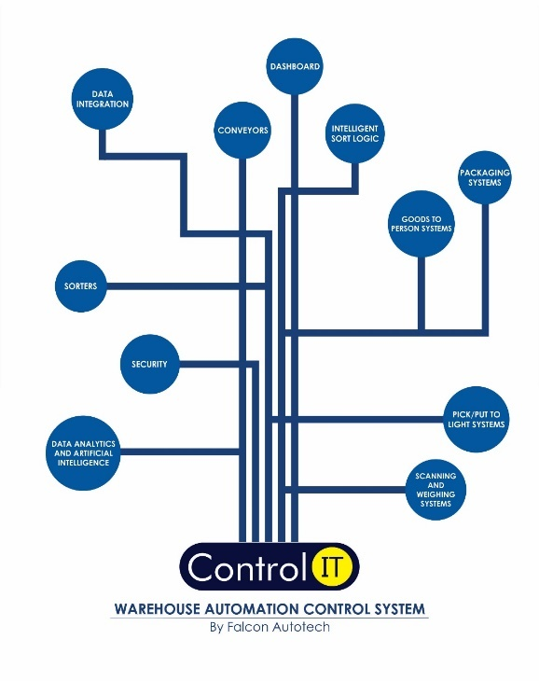

Key Values

Supported Protocols

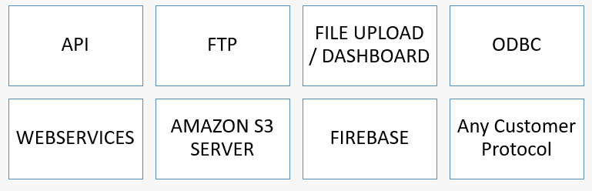

Falcon’s Visual Inspection System (SCADA)

SCADA stands for Supervisory Control and Data Acquisition. It is a system of hardware and software components that allows for remote monitoring, control, and data acquisition of industrial processes or facilities

The Visualization system provided by FALCON (or SCADA) allows the monitoring and control of the different systems delivered for the Flipkart Riyadh Hub. This SCADA system receives from each monitored sub-system all information on their operating status in real time.
At the system monitoring level, the functions performed are:
- Field data acquisition.
- Animated visualization of equipment.
- Representation of the operating mode of the system (nominal, contingency, etc.).
- Alarm management.
- Alarm history management.
- Diagnostic help.
- Failure detection.
- Equipment control.
- Statistics on equipment operation.
- Historical Statistical Report.
- Recording and archiving.
- Safety operator interface.

Key Components Make

Items | Make
Belts | Forbo/ Derko
Rollers | Falcon
Cross Belt Carriers | Falcon
Linear Synchronous Motors | Falcon/SEW
Feed Line Motors | Induction Motors – SEW/ Lenze
Weighing Conveyor | Metter/Beizerba
Barcode Scanner | SICK
Encoders | SICK
Sensors | Sick/Leuze/ P&F
PLC | Omron
Control Panels | Rittal/ BCH
VFDs | Siemens/Lenze/ AB/ Omron
Cables | LAPP/ Equivalent
Switch Gear | Schenider/Equivalent
Bearings | NTN/SKF/Equivalent
Power Transmission Systems | Vahle
HMIs | Siemens

Principle of Safety

E-Stops
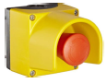

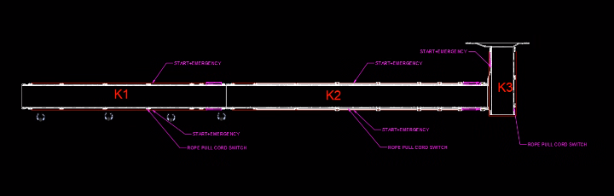
- At Every Conveyor Module – Both sides

Program Organisation

Program/ Project Schedule

S.No. | Activity | Timeline
1. | Receipt of PO | Week 0
2. | Project Kick off | Week 1
3. | DAP Submission | Week 4
4. | DAP Approval | Week 6
5. | Detailed Designing | Week 10
6. | Manufacturing & Procurement | Week 18
7. | Inhouse Assembly | Week 20
8. | Dispatch | Week 21
9. | Installation & Go Live | Week 26

*Above plan is tentative, detailed plan will be shared post order confirmation.

Program Management

For this program, proposed approach covers the following aspects:

- Creation and monitoring of the project plan.
- Communication with Flipkart
- Weekly/Fortnightly Meeting Flipkart to share the Project Status.
- Scheduling of the resource management.
- Management of risks and opportunities.
- Management of the requirements.
- Management of the list of anomalies or reservations.

Flipkart Responsibility

Flipkart Responsibilities During the Assembly and Commissioning Phase

- Provision of the site complex and office area facilities.

- Flipkart to provide HPT/ Forklift for material movement for complete duration.

- The possibility of authorizing access to the site and the execution of the installation work up to 7 days a week and 24 hours a day if deemed necessary and if requested by FALCON.
- Free provision, during the installation phase, of the power supply necessary for the installation activities (estimated at 20 kW).
- Provision, during the commissioning phase, of the power supply necessary for the operation of the shipment sorting system free of charge at the date of FALCON need.
- Provision of the IT system functionality in accordance with the specification at the date of FALCON need.
- The customer is responsible for a safe working environment.
- The customer makes arrangements for the working area(‘s) to be protected against direct weather influences.
- The customer provides adequate lighting, heating, and ventilation to create a normal working environment.
- The cost of temporary storage that may be required (other than in the immediate vicinity of the installation site) is not included in the scope of delivery of this quotation. This also applies to temporary storage that may be required because materials are ready for delivery (in accordance with the schedule) but cannot be delivered due to hold-ups on the customer's side.
- The customer is responsible for the demarcation of aisles and danger zones with floor paint.

Responsibilities of Flipkart During the Tests

- Provision of the test loads and barcode labels required for the tests.
- Provision of personnel required for test activities (loading and unloading operations).
- Provision of the necessary information to sort the shipments correctly.
- Verify with FALCON the quality and conformity of the test loads (labels, cartons).
- Will need to provide the necessary staff to collect information on the tests and to verify and confirm test results with FALCON.

Flipkart Responsibilities During the Training

- Free from their usual work, the employees participate in the training for the duration of the training.
- Provision of a list of participants for each available training course 3 days before the start of the course.

- Provision of a classroom equipped with a whiteboard, video projector, projection screen, and enough space for desks or tables and chairs for the trainer and trained staff.
- check the prerequisites of the people who have to follow the training, e.g. the qualifications of the technical staff.
- The invitation of staff to attend the training courses will be at the expense of FLIPKART.

Warranty Period
Falcon’s offered System comes with a standard warranty of 1 year (Starts from the date of beneficiary use).
The warranty covers the following support:
- 24 X 7 Telephonic, Email and Remote Service Support when required.
- Regular Software updates and Bug Fixes.
- Supply of Mechanical and Electrical components in case of failure (excluding damages as mentioned in the Exclusion Clause)
The warranty does not apply to the replacement or repair of:
- Normal wear and tear.
- Consumables.
- Faulty articles continued:
  - Failure to comply with the manufacturer's recommendations (logistics documentation, Technical Information Note, retrofit document) and the rules of the trade.
  - Negligence or abnormal use of equipment.
  - Anomalies produced by an environment of use, storage or transport that does not comply with the specifications or recommendations of Falcon: packaging, temperature, hygrometry, sector, insulation, etc.
  - A defect due to a cause external to the supplies and services of Falcon.
- Equipment other than that supplied by Falcon.
- Items that can be repaired exclusively by Falcon that have been repaired or attempted repairs other than those carried out by Falcon.
- Items that fail due to normal wear and tear of one or more of its components or whose tamper-evident seals (varnish, strip, etc.) have been broken or whose serial numbers have been removed or modified.
- Items damaged during transport to Falcon due to the use of unsuitable packaging.

Exclusions
The scope of supply includes all parts which are defined in the Supplier’s quotation.

All other parts which are not defined in the Supplier’s quotation do not belong to the Supplier’s scope of supply and are excluded. The following parts are also excluded:

- Server System
- Mobile Carts
- Construction Power
- Steel Works
- Pallets at chutes
- PC for SCADA.
- Stress free mats
- Insulation mats
- Fans at chutes & inducts.
- Building infrastructure; building structure, doors, fire exits, levelling devices, building extinguisher and fire alarm system, building heating and lighting system.
- Electrical power supply and wiring to the main control cabinets.
- UPS for Controls and Drives
- Network Cabling up to the Main Server Rack
- Intermediate wiring to parts which are to be supplied by the Purchaser/others.
- Emergency/Uninterruptable power supply
- Fire-alarm and fire protection devices
- Traffic and route markings
- Laydown Area
- Ram protection devices
- Cat walks, bridges, maintenance aisles and platforms
- Assembly tools like forklifts and hoisting machines
- All kind of network incl. Local Area Network (LAN/WLAN), exceeding the scope described in Scope of Supply
- Any Kind of Civil work
- Any adjustment of the Supplier’s scope of supply to local rules and regulations
- X-Ray machines
- Roller cages/ Pallets
- Simulation and 3D animation of the sorter system
- Interface with other equipment not specified in this offer.
- Provision of facilities for the control room (furniture, air conditioning, heating, etc.).
- The supply and installation of fencing around the different corridors.
- Any item specifically indicated as not forming part of the subject matter of the Seller's supply in the offer documentation.

